CURRICULUM VITAE
Mr. BIKASH PANDA
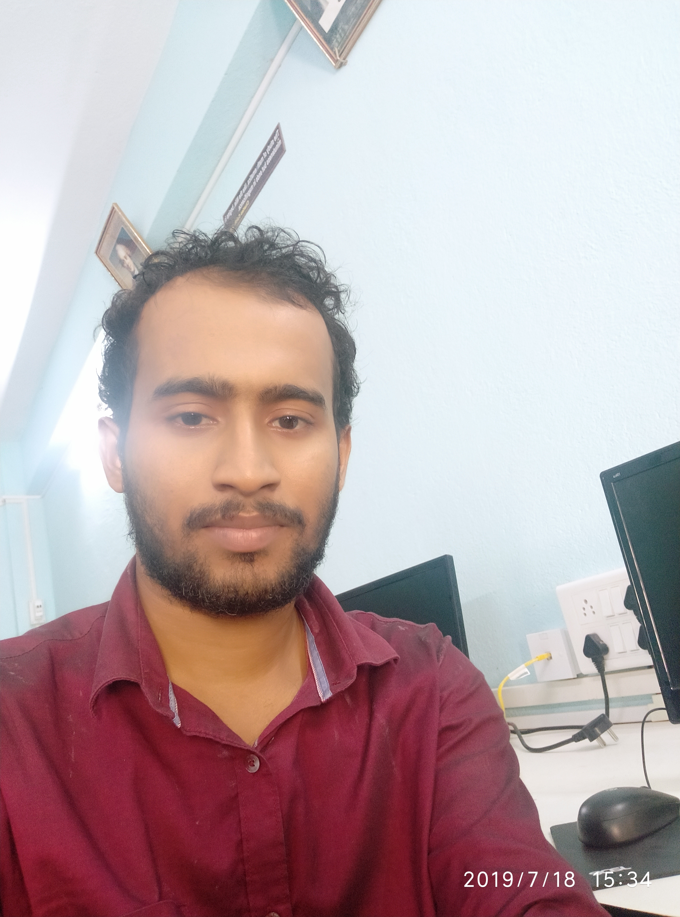
STATE AIDED COLLEGE TEACHER
DEPARTMENT OF MATHEMATICS (U.G &P.G)
MUGBERIA GANGADHAR MAHAVIDYALAYA
VIDYASAGAR UNIVERSITY
WEST BENGAL INDIA
CONTACT NO-8145309713
Email ID-bikashpanda96@gmail.com

PERSONAL PROFILE: -
• Father’s Name : Shiba pada panda
• Date of Birth | : | 11/03/1993
• Sex | : | Male
• Marital Status | : | Married
• Nationality | : | Indian
• Language Known | : | English, Hindi, Bengali
• Address : Vill-Palashi, P.O. - Jahalda
P.S.- Belda
Dist - Paschim Medinipur
West Bengal, Pin-721443

EDUCATIONAL QUALIFICATION: -
Examination passed | School/  College/Institute | University /Board | Year Of passing | % Of  Marks
MP | Jahalda High School | W.B.B.S.E | 2008 | 80.01
HS | Egra J. L  High School | W.B.C.H.S.E | 2010 | 77.6
BSC | Kharagpur College | VIDYASAGAR UNIVERSITY | 2013 | 58.9
MSC | VIDYASAGR UNIVERSITY | VIDYASAGAR UNIVERSITY | 2016 | 69.6

SPECIALIZATION: Real Analysis, Metric space, Topology, Linear Algebra
And Operation's Research

COMPUTATIONAL SKILLS: - Operating System-Windows
Programming Language- “C”
Software Packages- OpenFOAM
Mathematica, R, LaTeX
SCHOLARSHIPS &AWARDS: - Qualified NET in 2017 June

AIR(31)

TEACHING EXPERIENCE: -
Duration | Designation | Organization | Teaching Areas
24-07-2018 to 31-12-2019 | Guest Lecturer | Department Of  Mathematics  Mugberia Gangadhar Mahavidyalaya, Vidyasagar University | Under Graduate:  1st sem: Linear Algebra  2nd sem:  3rd sem;Real Analysis  4th sem:Real Analysis  5th sem: Statistics  6th sem: Metric space
01-01-2020 to till date | State Aided College Teacher | Department Of  Mathematics  Mugberia Gangadhar Mahavidyalaya, Vidyasagar University | Post Graduate:  1st Sem-Classical Dynamics  2nd Sem-Linear Algebra  3rd Sem-OR  4th Sem-OR

Participate in Seminars/Webinar/Workshop

Name | Organised by | Date
5-DAY NATIONAL WORKSHOP ON  OPTIMIZATION & FUZZY MATHEMATICS | Vidyasagar University, Midnapore, west Bengal, India | 9-13 September 2014
2nd International Conference on Recent Trends in Mathematics and its Application (ICRTMA 2015) | Vidyasagar University, Midnapore, west Bengal, India | March18-19 , 2015
Two day National seminar ICT and  Systematic Teaching Learning: Prospects and challenges in Rural setup | Mugberia Gangadhar Mahavidyalaya, Purba Midnapore, India | 4-5 December 2018
One day seminar on Green and clean Practises for a Green and clean campus | Mugberia Gangadhar Mahavidyalaya, Purba Midnapore, India | 19th December 2019
Enrichment Programme on Linear Algebra, Analysis, Differential Equation | Garhbeta College, Paschim Medinipore, Pin-721127 | 8-9 September 2020
National Level Webinar on Recent Trends in Applied Mathematics | Ramananda College, Bishnupur, Bankura, W. B, India | 16 th September 2020 (11.00 a. m-4. 00 p. m IST)
International Workshop on Geometry of Continued Fractions | University of Himachal Pradesh | September 14-15, 2020

- Punctuality
- Full commitment to my work and quick learner
- Ability to learn new things
- Willing to do anything

I declare that the above information is true at the best of my knowledge.

Date: -

Place: - Signature

